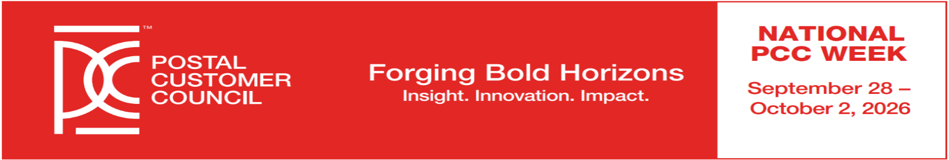
National PCC Day
Friday, October 2, 2026
Forging Bold Horizons – Insight. Innovation. Impact.

Dear Mailing Professional and Potential Exhibitor:

The Northern Ohio Postal Customer Council, in conjunction with the Steel Valley Postal Customer Council, cordially invites you and your organization to participate as an EXHIBITOR. This year’s event will be held at the USPS Administration Building, 2200 Orange Ave., Cleveland, OH 44101. The theme is “Forging Bold Horizons – Insight. Innovation. Impact.”

You will have the opportunity to meet and display to prospective and existing customers at this important annual Postal Customer Council meeting. You will receive recognition for your contributions and distribution of your company information.

Listed below are details for exhibitor registration and setup:

- Exhibit location selection will be on a first come, first serve basis.
- Exhibits will be comprised of a 6 ft. space containing one draped table. Electrical hook up is available at no charge, but you must provide your own power strips and extension cords.
- Exhibitors will receive two (2) admissions to PCC Day for each paid space, which includes Continental Breakfast. Additional admissions can be purchased at the current rate of $10.
- Exhibitors may give a 1-minute presentation during the Opening Ceremony to promote their company/services.
- The exhibit area will be available for set up the morning of the PCC Day between the hours of 8:30 a.m. and 9 a.m. The exhibits must be removed within one hour after the end of the event (by 1:00 p.m.).

EXHIBITOR OPPORTUNITIES
- All Exhibitors will have space on the PCC Day program including their logo and brief company description.
- Exhibitor cost is $50 per table.
- There will be time built into the program to meet and greet attendees and discuss your products or services.
- The Northern Ohio PCC reserves the right to screen vendors so that proper representation of the mailing industry is displayed.
- There is limited space, so make your reservations early!

Forging Bold Horizons – Insight. Innovation. Impact.
2026 National Postal Customer Council Day
Friday, October 2, 2026 - 9:00 am to 12:00 pm
USPS Administration Building, 2200 Orange Ave., OH 44101

EXHIBITOR REGISTRATION SUBMISSION FORM
Please Print or Type on this form.

Company Name: _____________________________________________________________________
Contact: _________________________________ Title: _______________________________
Address: ______________________________________________________________________
________________________________________________________________________
Phone #: _________________________ FAX #: _______________________________
Email: ________________________________________________________________________

Information about your company for the event program (25 words or less)

PARTICIPATION LEVEL:
Space/Table= 1 @ $ 50 each (One table per vendor permitted) TOTAL $ 50.00
Two Delegate Admissions per table (for registration):
- ______________________________________________________________
- ______________________________________________________________
Additional Admissions at $ 10.00 each TOTAL $ ____________
3) ____________________ 4) _____________________ 5) ________________
TOTAL ENCLOSED $ ______________
Do you need access to electricity? Yes____ No____

REGISTRATION DEADLINE IS September 18, 2026
Email logo to valentina.grabovez@usps.gov
Provide a PDF, JPEG or TIFF of your logo for printing.

Visit www.thenorthernohpcc.org (HOME Page) to make payment or mail check (payable to The Northern Ohio PCC and registration form by deadline September 18 to:
The Northern Ohio PCC, Attention: Tina Grabovez
2200 Orange Ave., #206
Cleveland, OH 44101
Information Concerning Exhibitor Registration, please contact Tina Grabovez, USPS, at valentina.grabovez@usps.gov/216-443-4723

