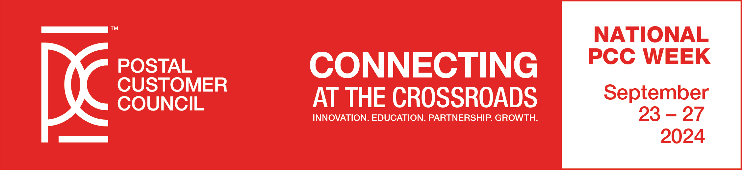
National PCC Day -- Friday, September 27, 2024

Dear Mailing Professional and Potential Exhibitor:

The Northern Ohio Postal Customer Council, in conjunction with the Steel Valley Postal Customer Council, cordially invites you and your organization to participate as an EXHIBITOR. This year’s event will be held at Corporate College Conference Center, 4400 Richmond Rd., Warrensville Heights, OH 44128. This year’s theme is “Connecting at the Crossroads.”

You will have the opportunity to meet and display to prospective and existing customers at this important annual Postal Customer Council meeting. You will receive recognition for your contributions and distribution of your company information.

Listed below are details for exhibitor registration and setup:

- Exhibit location selection will be on a first come, first serve basis.
- Exhibits will be comprised of a 6 ft. space containing one draped table. Electrical hook up is available at no charge, but you must provide your own power strips and extension cords.
- Exhibitors will receive two (2) admissions to PCC Day for each paid space, which includes Continental Breakfast and Lunch. Additional admissions can be purchased at the current rate of $70.00. *Please note that registration fee will be $80 per person after September 23.
- Exhibitors may give a 1-minute presentation during the Opening Ceremony to promote their company/services.
- Each Exhibitor can hold an individual contest for the drawing to occur before the end of the program.
- The exhibit area will be available for set up the morning of PCC Day between the hours of
7:30 a.m. and 8:00 a.m. The exhibits must be removed within one hour after the end of the event (by 2:30 p.m.).

EXHIBITOR OPPORTUNITIES
- All Exhibitors will be listed in the PCC Day program including their logo and brief company description.
- Exhibitor cost is $250 per table and more than one table per exhibitor is allowed.
- Your exhibits will be in an area where you will receive maximum exposure.
- There will be time built into the program to meet and greet attendees and discuss your products or services.
- The PCC reserves the right to screen vendors so that proper representation of the mailing industry is displayed.


Scan the QR Code and Register Today

EXHIBITOR REGISTRATION FORM
Presented by The Northern Ohio PCC in conjunction with the Steel Valley PCC
Friday, September 27, 2024 – 8:30 AM to 2:00 PM
Corporate College Conference Center
4400 Richmond Road
Warrensville Heights, OH 44128
(Please Print or Type this form)

Company Name:_________________________________________________________________________
Contact:_________________________________Title:____________________________________
Address:_________________________________________________________________________
__________________________________________________________________________
Phone #:_________________________________Fax:_____________________________________
Email:___________________________________________________________________________

Information about your company for the PCC Day Program (25 words or less):

Number of Spaces/Tables_____@ $250.00 TOTAL $______________________

Admissions per table included (fill out for registration):

1)______________________________________2)______________________________________________

Additional Admissions at $70.00 each* TOTAL $______________________

3)______________________________________4)______________________________________________

TOTAL ENCLOSED $_______________________

- Email logo to valentina.grabovez@usps.gov

REGISTRATION DEADLINE IS SEPTEMBER 13th
Make checks payable to The Northern Ohio PCC and mail check and registration form by deadline to:
Tina Grabovez, Customer Relations Coordinator, Ohio 1 District,
2200 Orange Ave., #206, Cleveland, OH 44101-9998
OR GO ONLINE AND PAY WITH CREDIT CARD AT www.thenorthernohpcc.org

For More Information Concerning Exhibitor Registration, please contact Tina Grabovez at 216.443.4723.
*Please note that registration fee will be $80 per person after September 23.

